
Draup Skills Architecture Support for GMR

© Draup, Inc. All Rights Reserved. www.draup.com • Email: info@draup.com • Fax 1281 362 2704• Phone (US) 1 281 362 2773, 1 408 716 8432
Correspondence: vijay@draup.com
Contents
Introduction 2
1. Scope of Work 3
2. Annexure-3A: Draup’s Approach to Skills-based Architecture - Methodology 4
i. Data Aggregation and Standardization 5
ii. Skills Taxonomy Development 6
iii. Workload Mapping & Levelling Framework 7
iv. AI Impact and Automation Potential 10
v. Quarterly Data Refresh and Governance 12
3. Annexure-3B: Project Management Team 14
4. Annexure-3C: Timeline 14
5. Annexure-3D: Sample data set 15
Conclusion: 15

Introduction

GMR Group, a leading global infrastructure conglomerate, operates across diverse sectors including airports, energy, highways, and urban infrastructure. In the AI-driven era, GMR faces the challenge of aligning its multi-sector workforce with rapid technological advancements and shifting skill demands. Traditional job architectures based on static roles and titles are no longer sufficient to keep pace with AI-led disruption. To stay competitive, GMR is partnering with Draup to implement a Skills Architecture Framework – a comprehensive, data-driven approach to transform workforce planning and talent management. This framework emphasizes skills over jobs, mapping out the specific competencies required across GMR’s business units and identifying how AI and automation will reshape work. The following document details the technical components of this Skills Architecture engagement, showcasing.
how it strategically aligns with GMR’s needs and the deep technical execution involved. Companies are navigating this paradigm shift, confronting the limitations of traditional job-based architectures that rely on fixed roles, rigid titles, and outdated hierarchical frameworks. The accelerating pace of AI-driven automation, the disruption of established skill sets, and the urgent demand for agile, adaptive talent strategies have rendered these conventional systems increasingly less effective. This necessitates a strategic pivot toward a skills-based architecture, an approach that prioritizes the identification, detailed mapping, and continuous development of specific competencies—encompassing root skills (foundational capabilities), core skills (domain-specific expertise), soft skills (interpersonal abilities), and technical stacks (digital proficiencies)—over the constraints of static job descriptions.
This document explores why companies must urgently adopt skills-based architecture in the current AI-driven era, provides an extensive array of real-world examples of emerging AI skills across diverse job families, examines the detrimental consequences of premature layoffs driven by GenAI adoption, and highlights how Draup, leveraging its advanced data-driven solutions and robust skills offerings. This document also aims to establish a strategic, future-ready Skills Architecture Framework for companies, providing a data-driven blueprint to enhance workforce agility, optimize talent mobility, and align skills with evolving business imperatives. By developing a granular Skills Taxonomy—integrated with company’s requirements — this framework will codify workloads, Tasks, Core Skills, Soft Skills, and the Technical Stack, ensuring a structured, insights-led approach to workforce transformation.

Scope of Work
The engagement with GMR is designed to build a future-ready workforce strategy anchored in a robust skills taxonomy, workload leveling framework, and AI impact analysis. The scope extends beyond a one-time diagnostic to deliver a dynamic, iterative architecture that ensures long-term adaptability and business alignment.

- Skills Taxonomy Development: We will design a structured skills architecture that captures both current and emerging requirements:
- Identification and classification of skills from GMR job descriptions leveraging Draup’s 19,500+ skill library.
- Categorizing skills into Root, Core, Emerging, Technology Stack, AI/ML Models, and Soft Skills at the role level.
- Defining proficiency tiers (from Basic to Advanced) benchmarked against global industry standards.
- Workload Mapping and Levelling Framework: The study will deconstruct roles into granular workloads and systematically define progressive levels of complexity:
- Identifying primary and secondary workloads across roles using Draup’s 850Mn+ JD database.
- Establishing workload-leveling structures aligned to task complexity, scope of responsibility, and depth of mastery.
- Defining transparent leveling criteria to support career pathing, performance management, and workforce planning.
- AI Impact and Automation Potential: The framework will quantify the disruption and augmentation potential of AI across GMR roles:
- Assessing AI-driven automation potential at the workload level.
- Differentiating between “disruption” of core workloads and “augmentation” of secondary workloads.
- Establishing an AI Impact Index to benchmark the net effect of AI on each role and enable scenario planning.
- Quarterly Data Refresh and Governance: To mitigate the risks of static frameworks, Draup will deliver a dynamic refresh model:
- Updating skills, workloads, and automation potential every quarter.
- Providing transparent change logs for all updates (added/removed skills, adjusted workload levels, revised automation percentages).
- Embedding governance mechanisms to institutionalize continuous workforce intelligence.

Annexure-3A: Draup’s Approach to Skills-based Architecture - Methodology

In an environment where AI-driven disruption is rapidly reshaping how infrastructure, aviation, energy, and urban operations are managed, GMR requires a workforce strategy that is adaptive, data-driven, and future-ready. Draup brings a proprietary skills architecture methodology designed to help organizations like GMR move beyond rigid, title-centric job structures toward workload-driven, skills-based architectures.

Built on extensive enterprise-grade data assets and AI-powered analytics, Draup’s approach addresses the urgent need for agile workforce planning, internal mobility, and transformation-readiness across GMR’s diverse business units. With access to 850M+ job descriptions, 17,500+ curated skills, and insights from 1.5M+ global enterprises, Draup operationalizes its solution into a comprehensive, scalable framework. This framework enables GMR to decode workforce complexity, align talent with business imperatives, and continuously redesign talent models in line with emerging technologies and sector-specific demands.
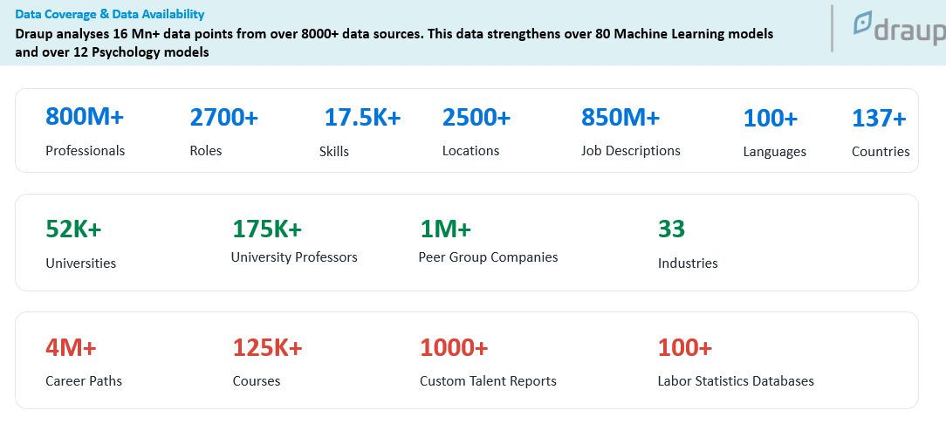
Draup’s Data coverage

Step-by-Step Approach
- Data Aggregation and Standardization: Draup begins by aggregating role-level data from multiple internal systems, including job descriptions, performance frameworks, and business-aligned capability matrices across all functions and regions. This data is standardized using an AI-enabled ETL engine to resolve regional language differences, structural inconsistencies, and semantic gaps. The standardized data layer serves as the foundation for a skill-first operating model. Internal datasets are merged and deduplicated against Draup’s proprietary job description and skills corpus, ensuring enriched, benchmark-aligned inputs for downstream modeling.
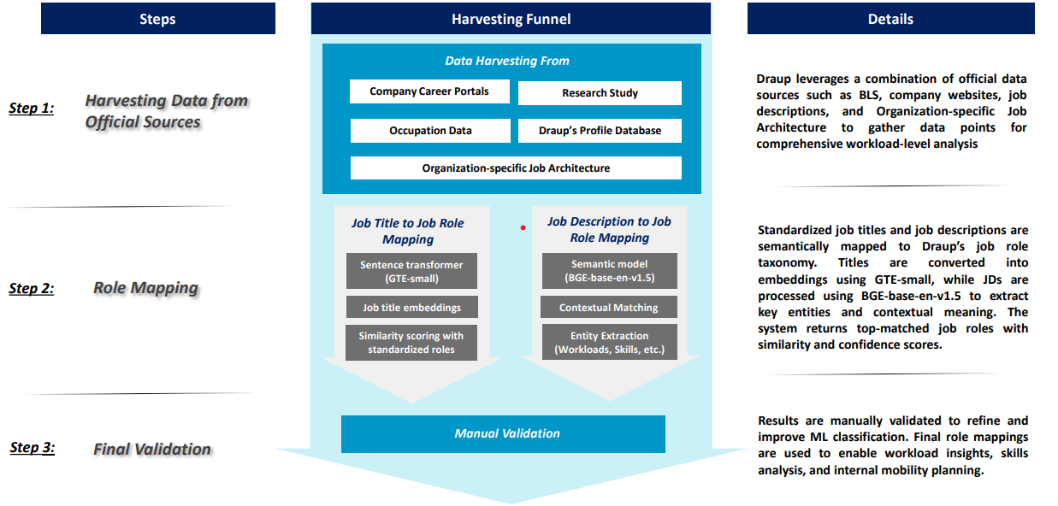
Draup’s Job Role Mapping Methodology
- Skills Taxonomy Development: At the core of the Skills Architecture is the development of a granular Skills Taxonomy tailored to GMR’s operations. Draup employs an AI-enabled process to extract and classify the skills required for every role in the organization. This begins by analyzing GMR’s job descriptions and workload data (the key tasks and responsibilities of each role) to identify relevant skill sets. Each extracted skill is then mapped against Draup’s extensive database of 17,500+ standardized skills organized into over 250 predefined clusters. This ensures that GMR gains a precise inventory of workforce competencies, covering both common and niche skills, and how they relate to one another.
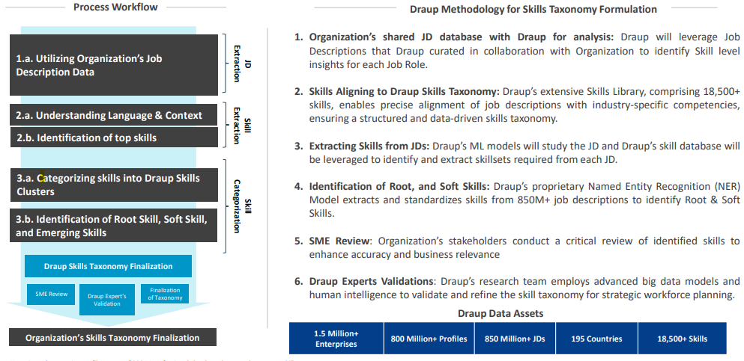
Draup’s Skill taxonomy development
  - Skills Taxonomy Structure: Draup’s methodology classifies identified skills into a structured, multi-tier taxonomy, which has been customized for GMR:
    - Root Skills: Fundamental capabilities that form the base for any advanced expertise in a role. These are foundational proficiencies (e.g. basic project management, safety compliance) that every employee in a role must possess. Root Skills serve as the starting point for developing higher-level competencies.
    - Core Skills: Domain-specific and critical skills that are directly tied to successful job performance and GMR’s strategic objectives. For example, a Core Skill for an Airport Operations Manager might be knowledge of aviation regulations, while for a Power Plant Engineer it could be expertise in turbine technology. Core Skills represent applied proficiency and decision-making ability in complex scenarios, enabling high-impact performance.
    - Soft Skills: Interpersonal and cognitive abilities that enhance collaboration, leadership, and adaptability. These include skills like communication, teamwork, problem-solving, and adaptability – increasingly important across all GMR sectors (e.g. coordinating diverse airport teams or managing stakeholder communications in urban infrastructure projects).
    - Technical Stack: The specific technical tools, technologies, and digital proficiencies required in the role. This includes industry-specific software, equipment, or methodologies. For instance, in GMR’s energy business, this might include using SCADA systems or AI-based predictive maintenance software, while in highway operations it could involve traffic management IoT systems. The Tech Stack category captures how digitally enabled a role is, aligning with GMR’s push for innovation and automation.
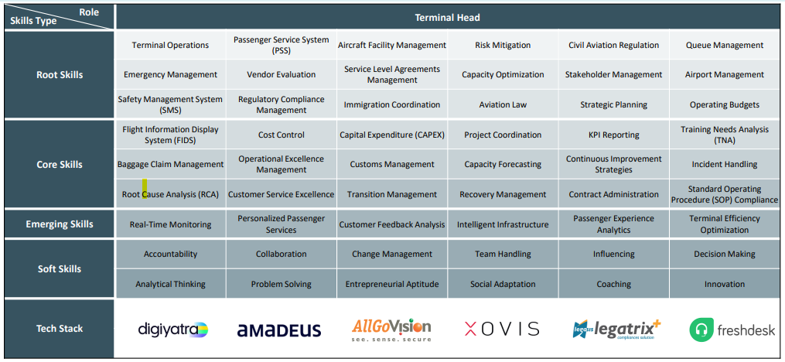
Skill taxonomy for Terminal head (for Illustrative use only)
By developing this detailed taxonomy, GMR achieves a common skills language across its diverse businesses. Every role – whether it’s an airport security officer, a highway project engineer, or an energy plant technician – is broken down into its constituent skills. This taxonomy becomes the foundation for numerous decision-making use cases. For instance, GMR’s HR and L&D teams can pinpoint skill gaps and target them with upskilling programs, ensuring the workforce is ready for emerging technologies. Leadership can use the taxonomy to drive precision workforce planning, aligning talent with business imperatives by ensuring critical skills (like AI-driven data analysis or sustainability management) are present where needed. Furthermore, the standardized skills framework allows GMR to benchmark its talent against industry peers, identifying areas where GMR leads (e.g. expertise in green energy technologies) or lags behind (e.g. AI software development skills). Overall, the Skills Taxonomy provides GMR with an actionable blueprint of its human capital, directly linking skills development to strategic goals.
- Workload Mapping & Levelling Framework: A pivotal element of the engagement is Draup’s Workload Mapping process, which deconstructs each job role at GMR into granular workloads and tasks. Workloads are the major responsibility areas of a role (for example, “Runway Operations Management” for an airport manager, or “Turbine Maintenance” for an energy engineer), and each workload is further broken down into specific tasks. By dissecting roles in this manner, GMR gains a clear view of what work is being done, independent of job titles. This clarity is crucial in a fast-changing environment – it reveals how tasks might be evolving with technology and where redundancies or overlaps exist across different roles.
From each workload, Draup identifies the associated tasks and maps them to the required skills (Core, Soft, Tech Stack, etc.). This Workload-Task-Skill mapping creates a detailed ontology of work. For example, in GMR’s highways division, a workload like “Toll Operations Management” might include tasks such as monitoring toll collection systems, responding to incidents on the highway, and analyzing traffic flow data. These tasks would link to skills: monitoring uses technical skills with IoT sensors, incident response needs soft skills in communication and decision-making, and traffic analysis requires analytical and possibly AI skills. Likewise, in the urban infrastructure segment, a role in city development might have workloads like “Project Planning” and “Regulatory Compliance”, each with tasks mapped to specific skills (project planning software proficiency, knowledge of urban regulations, stakeholder coordination, etc.).
Leveling Framework: By mapping workloads and tasks across roles, Draup helps GMR establish a job leveling framework that underpins consistent career progression and role design. The fine-grained analysis shows the relative complexity and impact of tasks in different roles, which informs how roles are leveled. For instance, a Level 1 (junior) Maintenance Technician in an energy plant might handle routine tasks such as equipment inspections and data logging, whereas a Level 3 (senior) Technician would take on complex tasks like diagnostic analysis using AI tools and supervising maintenance crews. Through workload mapping, these distinctions become clear, allowing GMR to define what capabilities distinguish one job level from the next. This ensures fairness and clarity in career paths – employees understand what skills and tasks they must master to advance.
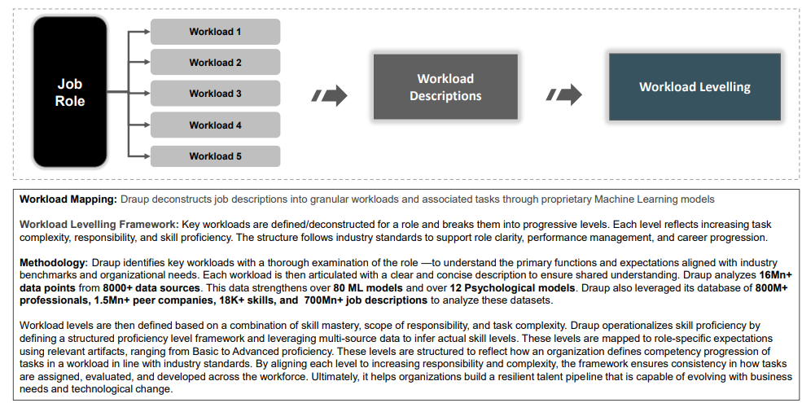Workload Levelling Framework
Furthermore, a structured Workload-Task-Skill taxonomy enables standardized career progression frameworks across GMR. It provides a data-driven basis for setting job levels, writing role descriptions, and evaluating performance. With this framework, GMR can ensure that a “Manager Level” role in airports has an equivalent level of responsibility and skill proficiency as a “Manager Level” role in energy or highways, fostering internal mobility. By clarifying job expectations and required competencies at each level, GMR can better guide employees in their career development and identify high-potential talent ready to take on larger roles. It also supports workforce planning decisions: GMR’s HR can identify if certain critical tasks (e.g. AI systems oversight) are over-concentrated in a few senior roles, indicating a need to train more staff at lower levels for redundancy and capacity building.
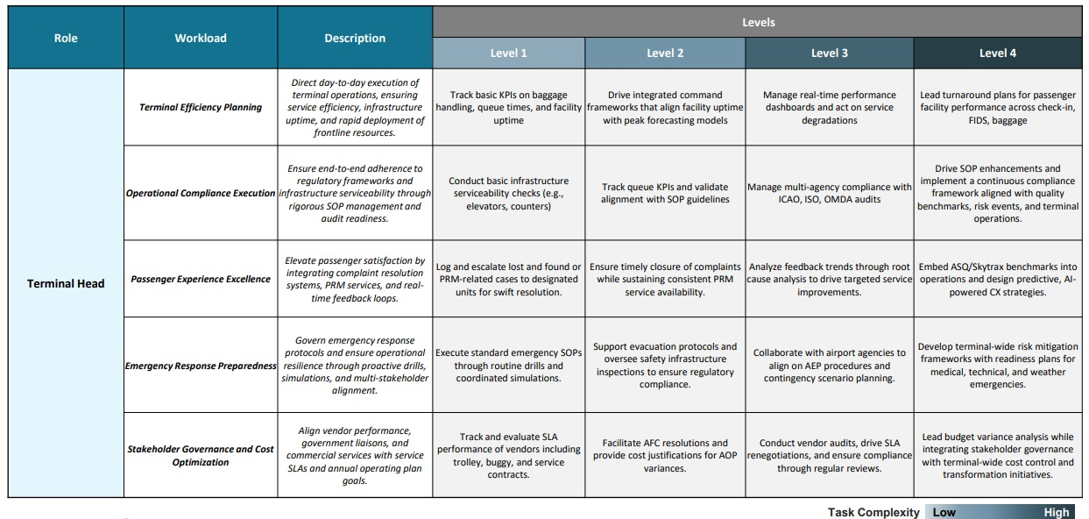Workload levelling framework for Terminal Head (For illustrative use only)
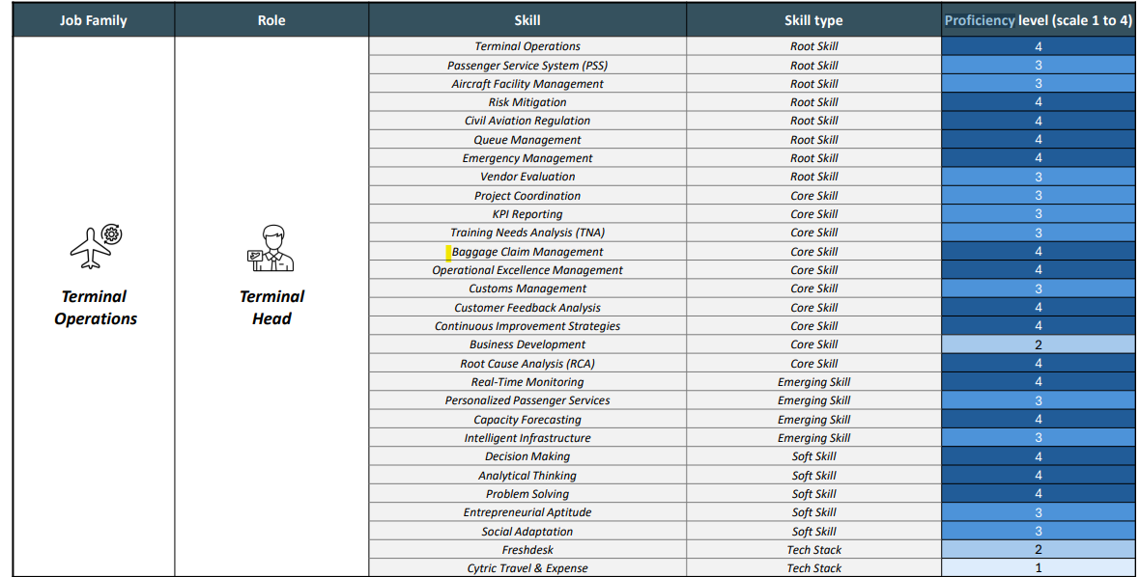
Skill Proficiency Levelling (for Illustrative use only)
In practice, the Workload Mapping and Leveling Framework drives both operational and strategic benefits for GMR. Operationally, it exposes opportunities to redistribute tasks – perhaps some tasks performed by senior engineers can be automated or handled by junior staff with the right training, thereby optimizing workload balance. Strategically, the framework gives leadership visibility into how work is structured and where to invest in either automation or talent development. Ultimately, this approach helps GMR maintain an agile and resilient workforce, where talent capabilities are aligned with business demands and employees have clear pathways for growth.
- AI Impact and Automation Potential: As part of the Skills Architecture engagement, Draup conducts an in-depth analysis of each role’s tasks to determine the impact of AI and automation – essentially, a Workload Transformation assessment. The goal is to identify which tasks can be augmented or fully automated by AI and to gauge how emerging technologies will reshape jobs at GMR. This involves leveraging Draup’s research and external data on industry trends, including labor statistics, market reports, and peer company practices. By synthesizing insights from hundreds of sources, Draup pinpoints specific tasks that are becoming candidates for AI automation and new tasks that are emerging as critical (often related to overseeing or collaborating with AI systems).
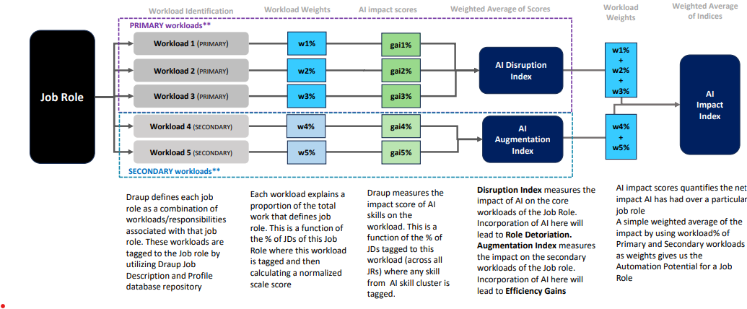
AI Impact index Methodology
For GMR, this analysis is highly contextualized to its key sector: - In the airports business, AI is increasingly used for tasks like baggage handling, security screening, and predictive aircraft maintenance. For example, many airports now use AI-driven systems to sort and route luggage or to scan security footage, which can free up staff from manual monitoring. Airlines and airports are leveraging AI for predictive maintenance of aircraft and equipment, identifying issues before failures occur. GMR’s airport operations can benefit from such automation, allowing ground crews and engineers to focus on higher-level safety oversight and passenger experience tasks rather than routine inspections. Additionally, passenger flow management can be enhanced by AI analytics that optimize staffing and services in real-time based on traveler volumes.
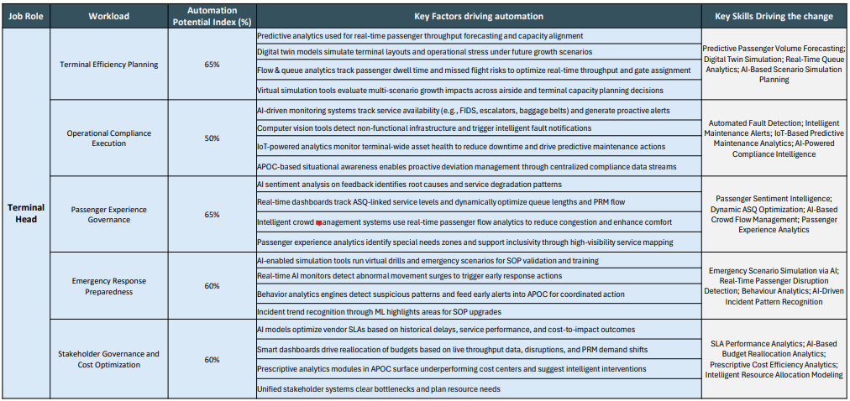
Skill Proficiency levelling for terminal head (For illustrative use only)
Draup’s analysis distills these trends into a clear AI Impact Scorecard for GMR. It highlights, for each role or workload, the degree of automation potential and the expected evolution of tasks. For instance, a role like Airport Security Analyst might see 40% of its tasks (such as initial CCTV monitoring or identity checks) become automated through computer vision and biometrics, while 60% of tasks (like threat assessment and incident response) remain human-critical but augmented by AI alerts. Armed with this insight, GMR can make informed decisions on how to restructure roles and reskill employees. Where high automation potential is identified, GMR may choose to retrain affected employees for new roles (e.g. a toll booth operator learning to become a traffic data analyst). Where AI creates new tasks or demands (for example, needing experts to manage AI systems or interpret AI outputs), GMR can proactively hire or develop talent in those areas.
The automation potential assessment also guides investment decisions. GMR’s leadership can prioritize which AI technologies to implement by looking at the ROI in terms of workload transformation – e.g. if automating a certain process in energy plants yields significant efficiency gains and can be managed with current staff after training, it becomes a high-priority initiative. This ensures that AI adoption is tied to clear productivity improvements and workforce readiness, avoiding pitfalls such as premature staff reductions. In fact, this framework helps prevent the risks of hastily automating without preparation; it encourages a balanced approach where humans remain “in-the-loop” to supervise AI and handle exceptions. By systematically evaluating AI impact on each part of the business, GMR can navigate the AI revolution with confidence – optimizing operations with automation while continuously empowering its employees with the skills to thrive in augmented roles.
- Quarterly Data Refresh and Governance: Implementing the Skills Architecture is not a one-time exercise – it requires ongoing updates and governance to remain relevant. GMR operates in fast-moving industries where new technologies (and thus new skills) emerge regularly, and organizational changes (new projects, acquisitions, etc.) can alter workforce needs. To address this, Draup has established a robust Quarterly Data Refresh and Governance process for GMR, centered on its Data Exchange capabilities.
Data Exchange Delivery: All Skills Architecture outputs – the skills taxonomy, workload mappings, benchmarks, and AI impact analyses – are delivered to GMR in standardized, machine-readable formats for easy integration. Draup supports a range of data formats and delivery methods, including:
- File Formats (CSV, Parquet, Avro): Batch data files in formats like CSV for spreadsheets or Parquet/Avro for big data platforms can be delivered via secure file transfer (e.g. SFTP or to a cloud bucket on AWS S3). This flexibility ensures compatibility whether GMR wants to load data into an HR analytics tool, a data warehouse, or a simple Excel report.
Enterprise System Compatibility: The delivered data is designed to plug into GMR’s existing systems with minimal friction. For instance, the skills taxonomy and employee skill profiles can integrate with GMR’s Human Resource Information System (HRIS) for talent management, or with its Learning Management System (LMS) to drive personalized training plans. The data can also feed into Applicant Tracking Systems (ATS) (to enhance recruitment by matching candidates’ skills) or project management tools used in infrastructure projects. By using common data standards and identifiers, Draup ensures that the skills data enriches GMR’s current digital ecosystem rather than existing in a silo. This broad compatibility – spanning HR platforms, talent analytics tools, and even operational systems – enables GMR’s teams (HR, department managers, etc.) to access up-to-date skills intelligence within their regular workflows.
Refresh Scheduling: Draup offers flexible refresh cycles, and for GMR a quarterly refresh cadence has been established (with the option to adjust frequency as needed). On a quarterly basis, Draup will update the data to reflect: any new roles or changes in job descriptions at GMR, emerging skills or technologies in the market, and evolution in AI impact as technologies mature. These updates are critical for keeping the Skills Architecture accurate. For example, if a new AI tool is introduced in airport operations, its associated skill (say, a new software proficiency) would be added to the taxonomy in the next refresh. Draup’s Data Exchange mechanism supports not only full data refreshes but also incremental updates. An incremental update will send only the changes (e.g. new skills added, obsolete skills removed, modified mappings), which can be more efficient for GMR’s IT to process. Alternatively, a full refresh ensures a complete snapshot if GMR prefers to overwrite the old data each time. These options allow GMR to choose the update method that best fits its data management strategy.
Governance and Change Management: Each quarterly refresh is accompanied by a transparent change log and governance workflow. Draup provides a detailed change log that highlights what changed since the last version – for instance, “10 new skills added (list...); 5 skills updated or reclassified; AI impact scores adjusted for 3 roles based on new data”. This change log enables GMR’s internal team to review and approve updates. GMR may form a governance committee (with HR, business unit representatives, and IT) to oversee the Skills Architecture. This committee uses the provided change logs to understand updates and ensure they align with GMR’s reality. If there are any questions (e.g. about the relevance of a newly added skill or the interpretation of an AI impact change), the governance process allows discussion and refinement.
Additionally, Draup maintains version control for all delivered datasets. Each quarterly release is tagged with a version number and date, so GMR can always reference or roll back to a previous version if needed. For example, if an update inadvertently contained an error, the system can revert to the last correct version while it’s fixed. Over time, this version history provides traceability – GMR can track how its competency framework has evolved year over year, which can be useful for auditing and measuring progress (such as tracking the increase in AI-related skills in the workforce over time).
Finally, the Data Exchange and governance framework ensure that the integration remains robust and secure. Automated validation checks are performed with each data push, and email notifications confirm successful transfers. Draup’s team monitors the data pipeline and quickly addresses any issues (e.g. a file format error or a connectivity issue) as part of the managed service. With these governance measures, GMR gains confidence that the Skills Architecture data is not only up-to-date but also accurate, well-managed, and aligned with its corporate data standards.
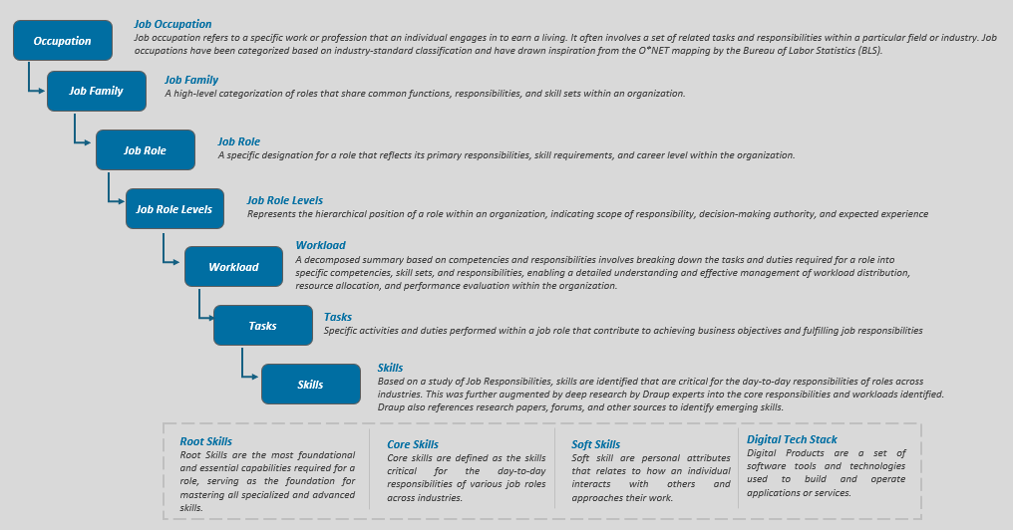

Draup’s expanded architecture of global skills

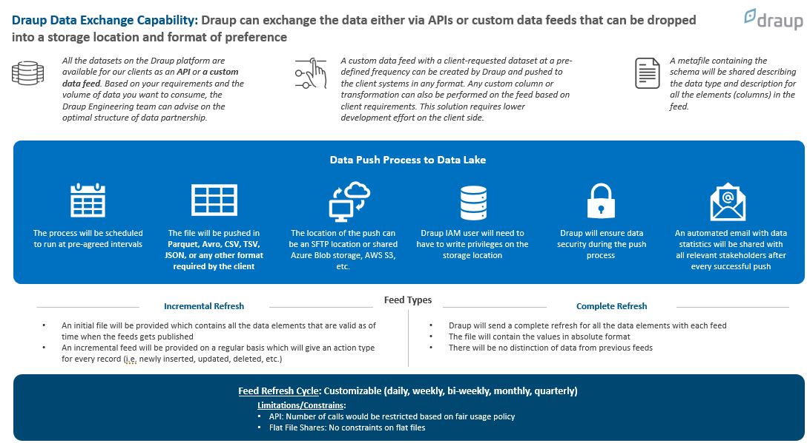
Draup Data Exchange Capabilities

Annexure-3B: Project Management Team
Please refer below who shall be responsible for executing the scope of work.

Name | Title | CV attached
Vishnu Shankar | Vice President - Research
Karthik Achar | Associate Manager - Research & Data Strategy
Harshit | Consultant

Annexure-3C: Timeline
Please refer responses in GMR_Enterprise_Grid_SkillsEngine_WorkforceSkilling-RFP (003).xlsx – row 33 to 35: Implementation, Adoption & Support

Annexure-3D: Sample data set
Please refer attached excel with sample set shared for four roles:

Conclusion:

The GMR Skills Architecture engagement with Draup serves as a strategic blueprint for building a future-ready workforce in an era of AI and digital transformation. By focusing on skills, workloads, and data-driven insights, GMR is transitioning from traditional job-centric talent practices to a dynamic, skills-first model. This comprehensive framework ensures that GMR’s talent strategy is tightly interwoven with its business strategy: every critical project or initiative can be mapped to the skills and people needed to execute it. The emphasis on Skills Taxonomy Development provides GMR with unparalleled visibility into its human capital, enabling informed decisions on where to upskill, where to hire, and how to deploy talent effectively. Through Workload Mapping and a levelling framework, GMR is strengthening its job architecture – clarifying roles, eliminating redundancies, and creating clear career pathways that motivate employees and attract top talent. The analysis of AI Impact and Automation Potential empowers GMR to embrace automation confidently and responsibly, reallocating human effort to high-value activities and ensuring the organization remains at the cutting edge of innovation in airports. Crucially, the Quarterly Data Refresh and Governance mechanism means this framework is not static; it will continuously evolve with GMR’s needs and the external landscape, supported by robust integration into GMR’s systems and oversight by its leadership.
By partnering with Draup and leveraging its advanced Skills Architecture Framework, GMR is positioning itself to achieve precision workforce planning, targeted reskilling, leadership pipeline development, and greater operational resilience. Decisions that were once based on intuition – such as which skills to invest in, which roles to redesign, or how to plan for emerging technologies – are now grounded in rich data and analytics. In a rapidly changing market, GMR’s agile, skills-driven talent ecosystem will be a source of sustainable competitive advantage, enabling the company to scale innovation and adapt faster than peers. Strategically, GMR is ensuring that its workforce is not only capable of meeting today’s demands but is also future-proofed for the challenges of tomorrow, driving continued growth and success in the AI era.
Ultimately, Draup’s Skills Architecture Framework serves as a strategic blueprint for enterprises seeking to thrive amidst rapid change. By fostering a culture of continuous skill development, promoting internal talent mobility, and aligning workforce strategies with long-term business goals, organizations can unlock the full potential of their human capital. This proactive, data-driven approach not only mitigates the risks of skill obsolescence and premature workforce reductions but also ensures that companies remain agile, innovative, and resilient in the face of ongoing technological and market evolution.

